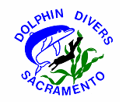

DOLPHIN DIVERS LABOR DAY WEEKEND
REGISTRATION FORM
September 2-5, 2016

Name:
Camping Fees: | Open to everyone $26 per night per vehicle  Only pay for Friday – Sunday nights. Any days before or after should be paid directly to the Ocean Cove Store
# of people attending
Vehicle #1 |  |  | x$26.00 per night = |  |  | $
Vehicle #2 |  |  | x $26.00 per night = |  |  | $
# pets |  |  | x $2.00 per night = |  |  | $
# of boats |  |  | Cost to be paid by DDS |  |  | $0.00
Spearfishing Contest: | Open to DDS members only (Sunday, Sept 4th) - Two person teams
Team Member #1 |  |  |  |  | x$10.00 | $
Team Member #2 |  |  |  |  | x$10.00 | $
Big Fish Entry: | Open to DDS members only (Sunday, Sept 4th) - Two person teams
# of entries |  |  | x $5.00 per person |  |  | $
Women’s Dessert Contest |  | Open to everyone (Saturday, Sept 3rd)
# of entries |  |  |  |  |  | $0.00
Total Camping and Contest Fees: |  |  |  |  |  | $
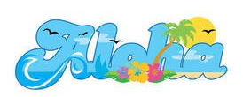

Make checks payable to: Dolphin Divers of Sacramento.
Send check and registration form to:
Marlyn Sepulveda, 2200 Weldon Way
Sacramento, CA 95825
Email: marlynhs@outlook.com Cell: (916) 768-0189
